Table of Content

S.N. Title Page No.

1. Introduction 1
2. Objective 2
3. System Study 3
3.1 Existing System 3
3.2 Problem Identification 3
3.3 Methodology 3
4. System Analysis 4
4.1 Requirement Specification 4
4.2 Data Flow Diagram 4
4.3 Data Dictionary 5
4.4 Feasibility Analysis 6
5. System Design 7
5.1 Flowchart 7
5.2 Database 8
5.3 Back and Front End Tool 8
6. Program Source Code 9
7. User Manual Guide 14
8. Conclusion 18

1. Introduction

This is the project of Fee Management System, which is helpful for the college management to fix and to enter the fee structure of different faculty in systematic way. This is also helpful for the students and their parents to know about the fee structure before admission. This project is applicable for any fee management section of any college.
2. Objective

The basic objective of the project:
-For the partial fulfilment of Computer Science education of BSc CSIT First Semester
-Replacement of current manual system by automated system,
Will be the reference for our followers etc.

3. System Study

The system is first studied to find whether there are problems or not. This initial investigation may also reveal that a new system is not required or not or the old one could be modified to handle the problem. If the detail investigation is recommended then we gather as many facts as possible about the current operating procedures and problems.

3.1 Existing System

Errors or problems in existing systems can trigger requests for systems projects. System errors must be corrected, but analysts often spend too much time reacting to day-to-day problems without looking at underlying causes. This approach can turn an information system into a patchwork of corrections and changes that cannot support the company's overall business needs.
The present situation of Fee Management System of MBM College is manual. When student rise their query about fee structure they cannot get updated information

3.2 Problem Identification

The problems identified in the current system are:
-Order wise entry of Fee Management System is difficult.
-Problem in updating data.

3.3 Methodology

Methodologies are the main method used in fact finding or information collection.
The number of methodology used for data collection are:
-We interviewed the members of management and account section.
-We discussed with some of the faculty members.

4. System Analysis

A detailed problem analysis is undertaken to better understand the nature, scope, requirements and feasibility of the new system.

4.1 Requirement Specification

Software requirements specification contains the requirements for the new system describes the alternatives that were considered and makes a specific recommendation to management.
This system of “Fee Management System” needs atleast pentium four computer with OS software of Windows-XP or above with 2GB space in harddisk.

4.2 Data Flow Diagram

Data flow diagram (DFD) is a method to illustrate how data flows in a system. DFD uses a number of symbols to represent systems. Most data flow modeling methods use four kinds of symbols to represent four kinds of system components: processes, data stores, data flows and external entities.

Search for Search for
Annual Fee Monthly Fee
Annual Fee Management Monthly Fee System Fee

Data Flow Diagram

4.3 Data Dictionary

A relational database system needs to maintain information about the entities attributes and constraints applied on them. This information is called the data dictionary or system catalogue. Among many of information the system must store the following:
- Name of Entity
- Names of Attributes
- Domain of Attributes (value that may be assigned to that attributed e.g. Y/N)
- Integrity constraints of each attribute and relation such as Primary Key for an Entity
S.N. | Variable Name |  | Type |  | Size | Validity
1 | x |  | Integer
2 | y |  | Integer
3 | i |  | Integer
4 | stream |  | Character
5 | admf | Integer
6 | mnthf | Integer
7 | annf | Integer
8 | lbf | Integer
9 | user | Character
10 | psass | Character
11 | NS | Character
12 | search | Character
13 | driver | Integer
14 | mode | Integer

4.4 Feasibility Analysis

In feasibility study for each solution it is checked whether it is practical to implement that solution. The outcome of feasibility study should answer: Is there an alternate way to do the job in a better way or what is recommended?

4.4.1 Technical Feasibility

In technical feasibility following points are taken into consideration:
Can the development of the proposed system be done with current equipment, existing software technology, and available personnel? Does it require new technology? Whether the required technology is available or not?

4.4.2 Economic Feasibility

In economic feasibility, cost benefit analysis is done in which expected costs and benefits are evaluated. The system is said to be economically feasible if the expected benefits equal or exceed the expected costs.

4.4.3 Operational Feasibility

Operational feasibility mainly concerned with issues like whether the system will be used if it is developed and implemented. Whether there will be resistance from users that will effect the possible application benefits. We have to consider some points as Does management support the project? Are the users not happy with current business practices? Etc.

5. System Design
The system design defines the functions and features of the system and the relationships among its components. The logical design includes the output that must be produced by the system, the input needed by the system, and the processes that must be performed by the system without regard to how tasks will be accomplished physically.

5.1 Flow chart
Flowchart is a technique used to depict or show the logical structure of computer programs. Logical control structure correspond different techniques like sequence, condition and iteration which refers the way in which the instruction in a program flow. Flowchart is independent of the language or it is common to all. So flowchart will be same for all languages. With the help of flowchart one can easily understand the program. He/she may run it efficiently and debugging can be done very easily.

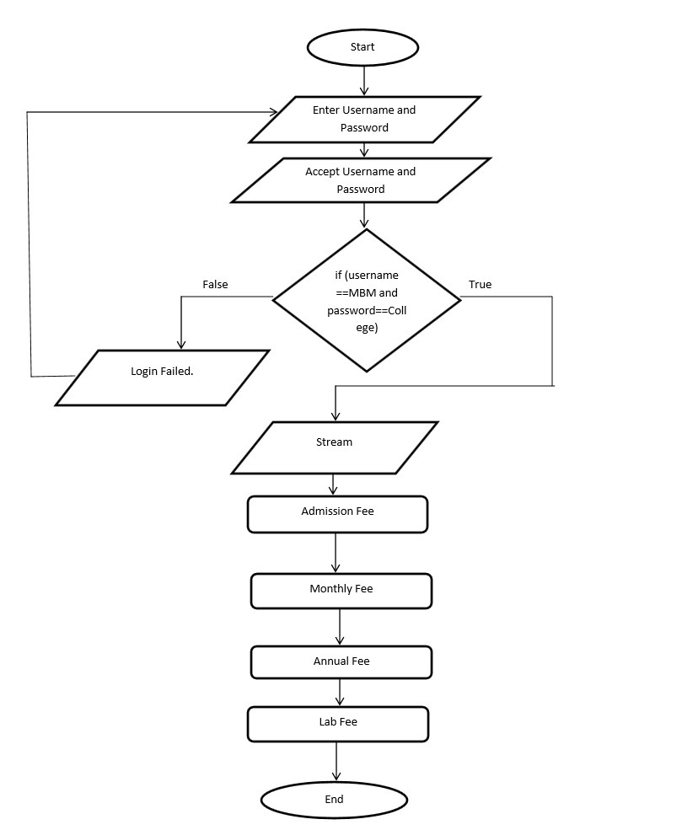
Flowchart diagram of Fee Management System
5.2 Database

A database contains a collection of related items or facts arranged in a specific structure. So database is a repository for collection of related data or facts. Database programs can also sort lists of data arranged them in alphabetical, numerical or chronological order.
For this software we are using flat file system where single table will include all the attributes of the table.

Table:
Stream | Admission fee | Monthly fee | Annual fee | Lab fee

5.3 Back and Front End Tool

As the front end the exe screen of the c Language is used and the data is stored in the excel file so it becomes the back end of the system.

6. Program Source Code

#include<stdio.h>
#include<conio.h>
#include<string.h>
#include<graphics.h>
FILE *fp;
int driver,mode;
void heading();
void main()
{
char user[10],pass[10],Stream[20],update[20],search[20];
int i,x,y,admf,mnthf,annf,lbf,driver,mode;
driver=DETECT;
initgraph(&driver,&mode,"");
heading();
settextstyle(1,0,6);
outtextxy(200,170,"WELCOME");
getch();
closegraph();
d:
heading();
printf("\n\n\n\n\n\n\n\n\n\n\t\tEnter Username:");
scanf("%s",user);
printf("\n\n\t\tEnter Password:");
scanf("%s",pass);
x=strcmp(user,"MBM");
y=strcmp(pass,"College");
if(x==0&&y==0)
{
printf("\n\n\t\tLogin Granted");
getch();
heading();
a:
printf("\n\n\n\n\n\n\n\n\n\n\t\tEnter 1 to Insert new data\n");
printf("\t\tEnter 2 to Update data\n");
printf("\t\tEnter 3 to Search data\n");
scanf("%d",&i);
switch(i)
{
case 1: b:
heading();
fp=fopen("MBM.XLS","a");
printf("\n\n\n\n\n\n\n\n\n\n\t\tEnter stream:");
scanf("%s",Stream);
fprintf(fp,"%s\t",Stream);
printf("\n\t\tEnter admission fee:");
scanf("%d",&admf);
fprintf(fp,"%d\t",admf);
printf("\n\t\tEnter monthly fee:");
scanf("%d",&mnthf);
fprintf(fp,"%d\t",mnthf);
printf("\n\t\tEnter annual fee:");
scanf("%d",&annf);
fprintf(fp,"%d\t",annf);
printf("\n\t\tEnter lab fee:");
scanf("%d",&lbf);
fprintf(fp,"%d\n",lbf);
fclose(fp);
for(i=1;i<=74;i++)
printf("*");
printf("\nStream\t\tAdmission Fee\tMonthly Fee\tAnnual Fee\tLab Fee\n");
for(i=1;i<=74;i++)
printf("*");
fp=fopen("MBM.XLS","r");
while((fscanf(fp,"%s%d%d%d%d",Stream,&admf,&mnthf,&annf,&lbf))!=EOF)
printf("\n%s\t%d\t\t%d\t\t%d\t\t%d",Stream,admf,mnthf,annf,lbf);
fclose(fp);
printf("\n\n\t\tPress 0 to return to main menu\n");
printf("\t\tpress 1 to enter another set of data \n");
printf("\t\tpress 2 to exit \n");
scanf("%d",&i);
switch(i)
{
case 0:goto a;
case 1:closegraph();
initgraph(&driver,&mode,"");
goto b;
case 2:closegraph();
initgraph(&driver,&mode,"");
goto c;
default:printf("Enter Valid Number");
break;
}
break;
case 2:closegraph();
initgraph(&driver,&mode,"");
heading();
fp=fopen("MBM.XLS","r");
printf("\n\n\n\n\n\n\n\n\n\n\t\tEnter stream:");
scanf("%s",update);
while((fscanf(fp,"%s%d%d%d%d",Stream,&admf,&mnthf,&annf,&lbf))!=EOF)prin
{
if(strcmp(update,Stream)==0)
{
fclose(fp);
fp=fopen("MBM.XLS","w");
fprintf(fp,"%s\t",Stream);
printf("\n\t\tEnter new admission fee:");
scanf("%d",&admf);
fprintf(fp,"%d\t",admf);
printf("\n\t\tEnter new monthly fee:");
scanf("%d",&mnthf);
fprintf(fp,"%d\t",mnthf);
printf("\n\t\tEnter new annual fee:");
scanf("%d",&annf);
fprintf(fp,"%d\t",annf);
printf("\n\t\tEnter lab fee:");
scanf("%d",&lbf);
fprintf(fp,"%d\t",lbf);
fclose(fp);
fp=fopen("MBM.XLS","r");
fscanf(fp,"%s%d%d%d%d",Stream,&admf,&mnthf,&annf,&lbf);
for(i=1;i<=74;i++)
printf("*");
printf("\nStream\t\tAdmission Fee\tMonthly Fee\tAnnual Fee\tLab Fee\n");
for(i=1;i<=74;i++)
printf("*");
printf("\n%s\t%d\t\t%d\t\t%d\t\t%d\n",Stream,admf,mnthf,annf,lbf);
}
}
break;
case 3:closegraph();
initgraph(&driver,&mode,"");
heading();
printf("\n\n\n\n\n\n\n\n\n\n\t\tEnter stream to search:");
scanf("%s",search);
fp=fopen("MBM.XLS","r");
for(i=1;i<=74;i++)
printf("*");
printf("\nStream\t\tAdmission Fee\tMonthly Fee\tAnnual Fee\tLab Fee\n");
for(i=1;i<=74;i++)
printf("*");
while((fscanf(fp,"%s%d%d%d%d",Stream,&admf,&mnthf,&annf,&lbf))!=EOF)
{
if(strcmp(search,Stream)==0)
{
printf("\n%s\t%d\t\t%d\t\t%d\t\t%d\n",Stream,admf,mnthf,annf,lbf);
}
}
fclose(fp);
getch();
break;

}

}
else
{
printf("\n\n\t\tLogin failed");
printf("\n\t\tEnter 1 to end the program\n\t\tEnter 0 to try again");
e:
scanf("%d",&i);
switch(i)
{
case 0:goto d;
case 1:goto c;
default:printf("\n\t\tenter either 0 or 1");
goto e;
}
}
c:
getch();
}
void heading()
{

driver=DETECT;
initgraph(&driver,&mode,"");
settextstyle(4,0,4);
outtextxy(90,10,"Madan Bhandari Memorial College");
settextstyle(1,0,2);
outtextxy(165,50,"Vinayaknagar,Kathmandu");
settextstyle(1,0,3);
outtextxy(230,70,"Project On");
settextstyle(1,0,3);
outtextxy(155,100,"FEE MANAGEMENT SYSTEM");
}
7. User Manual Guide

This is a welcome page of our project on Fee Management System.

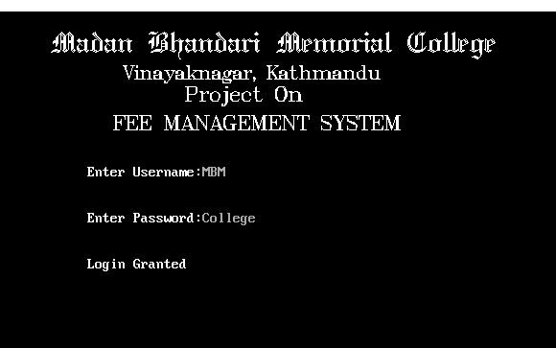
This is the 2nd frame of our project in this we can enter Username and Password. If username and password both are correct then we can go to another frame otherwise we can’t.

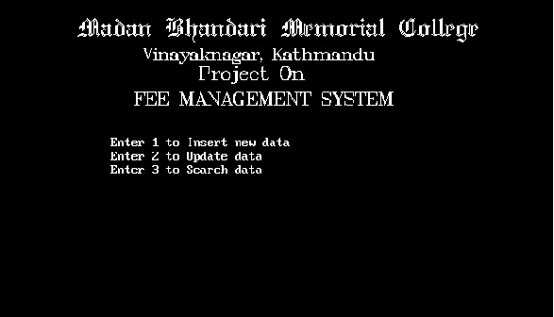This is the 3rd frame of our project which contain main menu. It gives option for user to Insert, Update , Search.

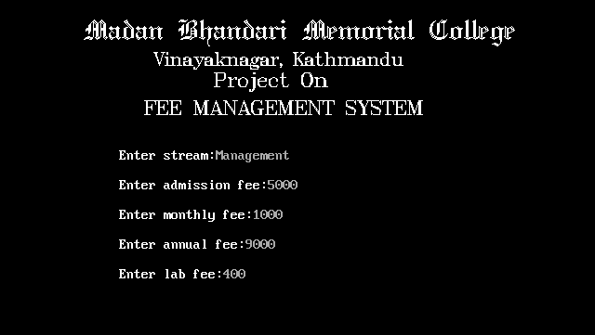
This is the 4th frame of our project. This frame appears if user Enter 1 to insert required data.

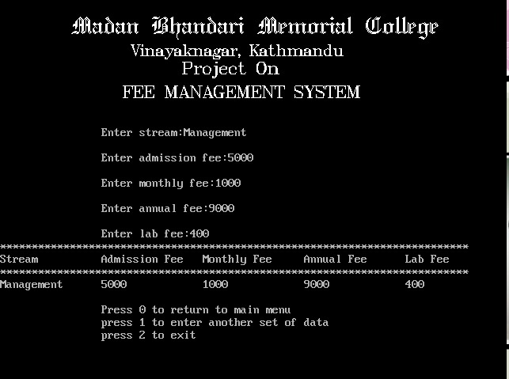

This is a 5th frame of our project which user can observe after entering data.

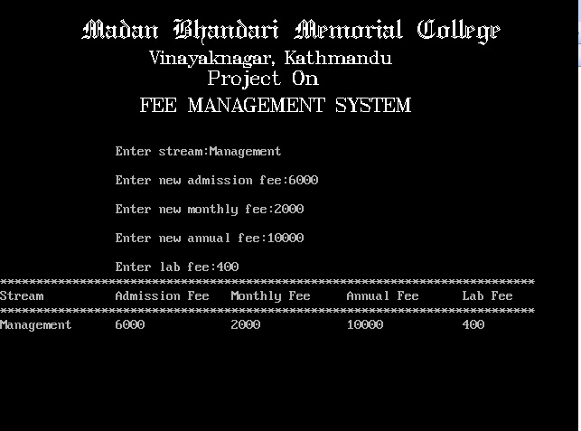
This is the 6th frame of our project in which user can Update old data after entering 2 from main menu.
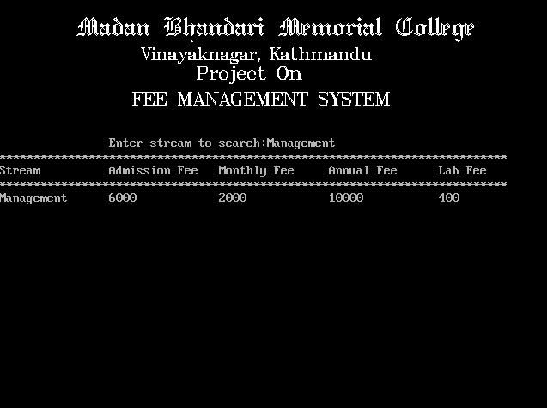
This is the 7th frame of our project which we can see after entering 3 to Search saved data.

8. Conclusion

After the detailed study of “Fee Management System” of Madan Bhandari Memorial College, we have developed this system.
Bibliography

1. ANSI C programming by E.Balagurusamy
2. Let us C by Yashavant Kanetkar
3. www.sarbagyastha.com.np

